MIRAVERSEOSX

MERIDION
A Worldbuilding & Story Bible
A chronicle of the realms, their peoples, histories, customs, and hidden truths

Contents
I. The World of Meridion
II. The Founding and the Ages
III. Geography and the Seven Realms
IV. Royal Houses and Government
V. The Seven Color Houses
VI. House Belonging and the Tribunal
VII. MAI, PRISM, AETHERCORE and the Veil
VIII. The Heavens and the Calendar
IX. Civic Life, Knowledge, and Institutions
X. Places, Residences, and Travel
XI. Figures, Relationships, and Hidden Histories
XII. Citizen Communication
XIII. Careers and Continuing Endeavors
XIV. Community Economy and Public Life
XV. A Lexicon of Meridion

I. The World of Meridion
Meridion is a sovereign world of seven realms whose inhabitants live among ancient allegiances, advanced civic institutions, ritual traditions, and the unseen architecture of resonance. Its cities are not simply settlements built upon ordinary earth. Beneath their streets and beneath the narratives that societies tell about themselves runs the PRISM, a deeper ordering of memory, matter, emotion, and energy. To most citizens, life is measured in ordinary acts: study, work, friendship, home, obligation, celebration, and mourning. The extraordinary is woven through the ordinary rather than replacing it.
Aureline, the civic and imperial heart of Orynvell, occupies an exceptional place in the country’s political and metaphysical geography. It is the site of royal legitimacy and an immense hidden structure called the AETHERCORE. Northwake and Nephele, though distant in character, are also important in accounts of rare passage into the Veil. The realms remain distinct in their climates, histories, and lineages while participating in the order established at Meridion’s founding.

Realm and House
Two sevenfold arrangements exist and must never be mistaken for one another. The Seven Realms are territorial and political divisions associated with royal lineages. The Seven Color Houses are social and resonant affiliations organized around different domains of human and metaphysical concern. A citizen may live in one realm, descend from a family rooted in another, be born to one Color House, and presently belong to another. None of these affiliations automatically proves membership in a royal dynasty.

II. The Founding and the Ages
The history of Meridion is reckoned around the coronation of Maeryn Seraphima. The year of her coronation is Year 0, and the years preceding her are remembered as Before Maeryn (BM). The calendar year begins in January, even in the founding year; March 6 marks the coronation and foundation of the sovereign state.
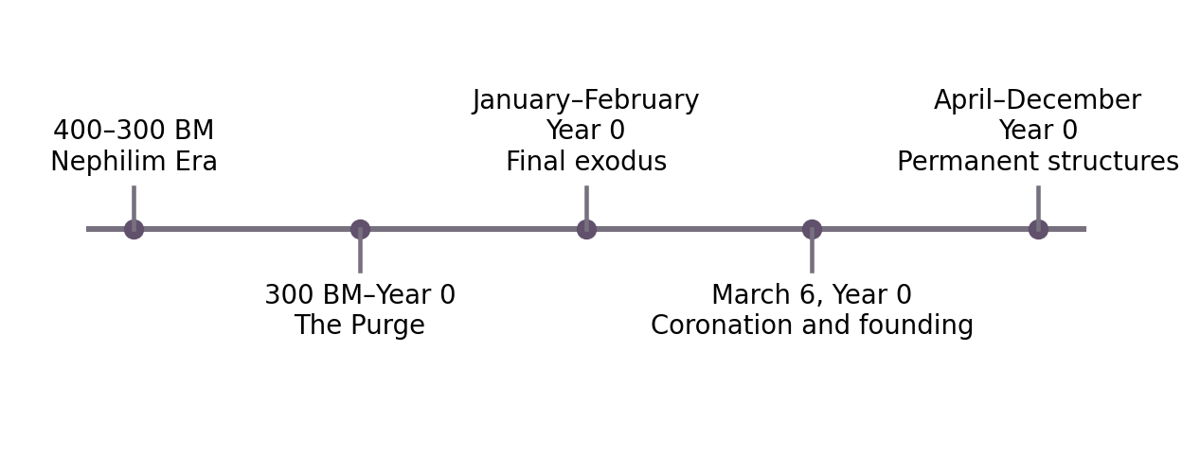

The Nephilim Era (400–300 BM)
The centuries preceding the founding of Meridion were not empty prehistory. During the Nephilim Era, accounts of angelic descent emerged beside evidence of extraordinary resonance phenomena. Later records would associate these events with questions of origin and with the hidden seventh frequency. Such associations do not by themselves establish when the Color Houses were founded, who first named their domains, or whether resonance preceded the Nephilim. Those relationships remain open parts of the world’s deeper history.

The Purge (300 BM–Year 0)
Beginning around 300 BM, the Purge unfolded over roughly three centuries. The surviving chronology describes systematic suppression and violence against bloodlines connected to forbidden lines of resonance. The loss was cultural as well as human: records disappeared, knowledge was hidden, and communities learned to treat some truths as dangerous. The Purge helps explain the political importance of preserved lineage, contested archival material, and the fear surrounding traces that established institutions cannot comfortably classify.

The Final Exodus and Founding
The final phase of flight is placed in January and February of Year 0. On March 6, Maeryn Seraphima was crowned and the sovereign founding of Meridion took place. The Seven Realms Concord belongs to this founding moment. The remainder of the first year was occupied by consecration, settlement, and the construction of permanent civic and archival structures at Aureline. March 6 is remembered as Founding Day. The Era of Maeryn begins at Year 0 and continues through the present chronological framework.
After the founding, the first permanent structures were established in Orynvell. The continuing age is known as the Era of Maeryn. Every March 6, Founding Day commemorates the passage from flight and persecution into sanctuary and sovereignty.
Period | Historical account
400–300 BM | The Nephilim Era: descent, hidden lineages and early records.
300 BM–Year 0 | The Purge: centuries of suppression and forced erasure.
January–February, Year 0 | Final flight and migration toward sanctuary.
March 6, Year 0 | Coronation of Maeryn Seraphima and foundation of Meridion.
Year 0 onward | The Era of Maeryn.

III. Geography and the Seven Realms
Meridion’s geography cannot be reduced to seven colors on a map. Its climates and waterways shape routes of trade, ceremonial identity, settlement, danger, and everyday labor. Each realm bears an elemental or seasonal association, but those associations coexist with inhabited towns, administrative centers, and overlapping political concerns.
Realm | Capital / seat | Royal House
Orynvell | Aureline | Seraphima
Fross | Southwake; Northwake fortress | Holly
Lumia | Rhyna | Lucia
Marlowe | Island City | Neryx
Brisland | Elodia | Yoko
Kaji | Balisya | Ember
Nephele | Serafin | Keket

Orynvell
Orynvell is associated with aether / celestial. A sacred imperial seat associated with legitimacy, succession, celestial authority, and the approaches to AETHERCORE. Angel Bay lies along its ceremonial coast. Its royal lineage is Seraphima; its capital or principal civic anchor is Aureline.
The ruling royal lineage is House Seraphima. Its capital or principal seat is Aureline.

Fross
Fross is associated with winter / ice. Glacial shelves, permafrost, winter rites, and the Northold Ocean define its imposing northern territory. Its two principal centers have distinct civic and defensive roles. Its royal lineage is Holly; its capital or principal civic anchor is Southwake; Northwake is a northern fortress.
The ruling royal lineage is House Holly. Its capital or principal seat is Southwake; Northwake fortress.

Lumia
Lumia is associated with summer / light. Solar ceremony, public legitimacy, and warm sunlit landscapes shape the realm; the Glowing Gulf of Meri is one of its notable geographical associations. Its royal lineage is Lucia; its capital or principal civic anchor is Rhyna.
The ruling royal lineage is House Lucia. Its capital or principal seat is Rhyna.

Marlowe
Marlowe is associated with spring / water. An island realm of estuaries, tides, rain, renewal, and sanctuaries; the Marlie Sea connects it to the wider world. Its royal lineage is Neryx; its capital or principal civic anchor is Island City.
The ruling royal lineage is House Neryx. Its capital or principal seat is Island City.

Brisland
Brisland is associated with autumn / air. Trade winds, migration routes, cultural preservation, and autumnal landscapes define its civic character. Its royal lineage is Yoko; its capital or principal civic anchor is Elodia.
The ruling royal lineage is House Yoko. Its capital or principal seat is Elodia.

Kaji
Kaji is associated with volcanic / fire. Kailo Islands, Kanifan Deserts, and the Volcanic Fields of Pyre lie within a unified realm of geothermal forces, craft, and volcanic industry. Its royal lineage is Ember; its capital or principal civic anchor is Balisya.
The ruling royal lineage is House Ember. Its capital or principal seat is Balisya.

Nephele
Nephele is associated with darkness / nether. Ancestral depths, obsidian spaces, hidden law, and twilight atmospheres mark the realm. Traditions surrounding concealed knowledge and the Veil are especially significant. Its royal lineage is Keket; its capital or principal civic anchor is Serafin.
The ruling royal lineage is House Keket. Its capital or principal seat is Serafin.

Seas, Islands and Borderlands
The Marlie Sea provides a central maritime expanse connecting Orynvell, Marlowe, and Brisland. The Northold Ocean borders Fross; Angel Bay opens beside the sacred capital of Orynvell; the Glowing Gulf of Meri is remembered for its luminous waters. Distinctive internal landscapes include the Kailo Islands, Kanifan Deserts, and Volcanic Fields of Pyre in Kaji, and the frozen fields and glaciers of Fross. Their specific coastlines and distances are best understood through Meridion’s established map rather than inferred from prose alone.
Among the named lands within Kaji are the Kailo Islands, the Kanifan Deserts, and the Volcanic Fields of Pyre. Fross is marked by glaciers and northern fields; the Marlie Sea, Northold Ocean, Angel Bay and Glowing Gulf of Meri belong to Meridion’s wider geographic memory.

IV. Royal Houses and Government
Seven royal lineages are associated with the seven realms: Seraphima, Holly, Lucia, Neryx, Yoko, Ember, and Keket. The founding monarchy is explicitly matriarchal in its historical account, and Queen Maeryn Seraphima is central to national chronology. Royal families govern territorial realms; their authority is not equivalent to membership in the Color Houses, even when a person or institution belongs to both worlds of influence.
House Seraphima holds the imperial throne in Orynvell. Houses Holly, Lucia, Neryx, Yoko, Ember and Keket govern the other realms. The royal order gives each region its own history, ceremonial obligations, political alliances and responsibilities toward the realm as a whole.
The Royal Council draws its authority from the seven territorial realms. It is distinct from the institutions governing Color House affiliation. Matters of succession, diplomacy, public order, border security and the balance between imperial and regional authority are inseparable from the realm lineages.

V. The Seven Color Houses
The Seven Color Houses are organized around domains rather than territorial borders. Six are linked to named governing Houses. The seventh, White, occupies a singular position: it is associated with truth, origin, and hidden resonance, but no governing House is publicly established. The uncertainty surrounding White is part of the world’s history, not an absence to be filled by inventing a ruling surname.
Color House | Associated domain | House
Crimson | Power, ambition, dominance | Kael
Violet | Knowledge, illusion, memory | Vexara
Gold | Wealth, commerce, influence | Aurelith
Teal | Healing, empathy, connection | Solenne
Silver | Technology, logic, systems | Nythos
Emerald | Nature, growth, balance | Veradis
White | Truth, origin, hidden resonance | The Unbound

Crimson
Crimson is associated with power, ambition, dominance and is governed by House Kael. These are domains of influence and identity; they should not be reduced to stereotypes of personality, and no single citizen must embody every trait of the House. Its relationship to other Houses is partly social, partly institutional, and potentially resonant.

Violet
Violet is associated with knowledge, illusion, memory and is governed by House Vexara. These are domains of influence and identity; they should not be reduced to stereotypes of personality, and no single citizen must embody every trait of the House. Its relationship to other Houses is partly social, partly institutional, and potentially resonant.

Gold
Gold is associated with wealth, commerce, influence and is governed by House Aurelith. These are domains of influence and identity; they should not be reduced to stereotypes of personality, and no single citizen must embody every trait of the House. Its relationship to other Houses is partly social, partly institutional, and potentially resonant.

Teal
Teal is associated with healing, empathy, connection and is governed by House Solenne. These are domains of influence and identity; they should not be reduced to stereotypes of personality, and no single citizen must embody every trait of the House. Its relationship to other Houses is partly social, partly institutional, and potentially resonant.

Silver
Silver is associated with technology, logic, systems and is governed by House Nythos. These are domains of influence and identity; they should not be reduced to stereotypes of personality, and no single citizen must embody every trait of the House. Its relationship to other Houses is partly social, partly institutional, and potentially resonant.

Emerald
Emerald is associated with nature, growth, balance and is governed by House Veradis. These are domains of influence and identity; they should not be reduced to stereotypes of personality, and no single citizen must embody every trait of the House. Its relationship to other Houses is partly social, partly institutional, and potentially resonant.

White
White stands apart from the other affiliations. Its domain concerns truth, origin, and hidden resonance. It is linked in the inherited lore to the Unbound and to a suppressed seventh frequency, but its governing lineage is not known or publicly acknowledged. Whether its members are officially recognized, how its affiliation is recorded, and what its true origins mean remain major mysteries. The account does not transform those uncertainties into settled facts.

VI. House Belonging and the Tribunal
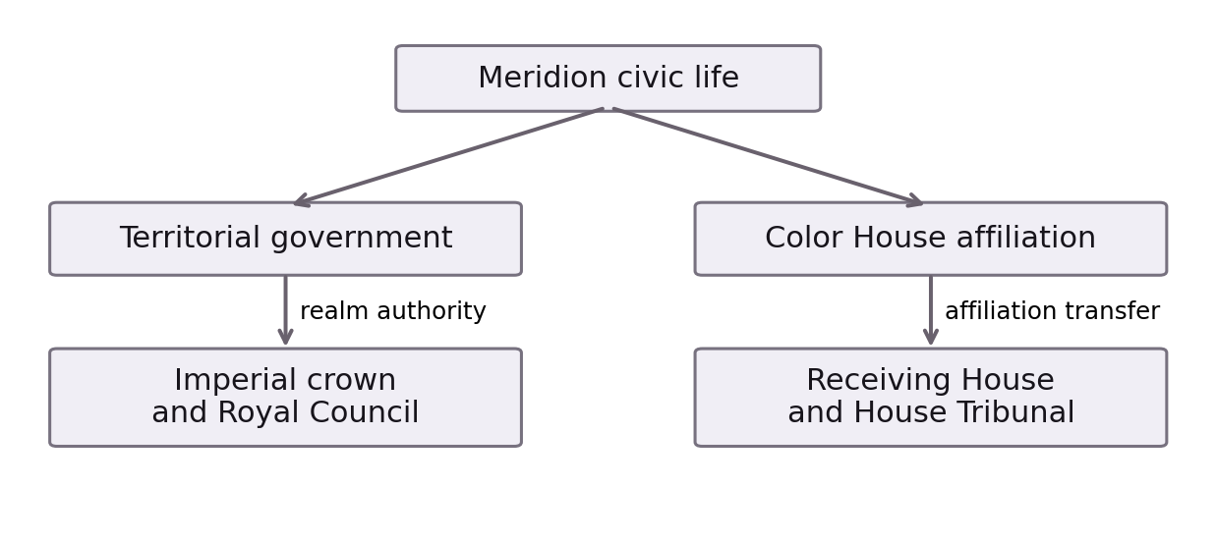

Birth and Affiliation
Every citizen possesses a Primary House, fixed at birth, and a Secondary House that records current affiliation. The Primary House does not change with later allegiance, residence, schooling, occupation, or transfer. The Secondary House can change, but only through an uncommon and formal legal process. The two may coincide. A change of Secondary House does not retroactively erase birth, ancestral memory, or previous membership.

The House Tribunal
The central authority for transfers is the House Tribunal, which operates independently of the territorial authority of the Seven Royal Houses. A transfer requires joint authorization by the receiving Color House and the Tribunal. The House being left is informed through the legal process but does not possess an automatic veto. This distinction preserves both the receiving House’s responsibility for admission and a wider safeguard of procedural fairness.
The Tribunal follows a mixed judicial model. Independent judges sit alongside Color House representatives, and authorization requires a separate majority within each group. A numerical example of three independent judges and four House representatives has been considered, but the final size of the institution is not fixed. Regardless of seat count, a bare majority of all members cannot override the failure to secure the required majority of either group.

Petitions and Appeals
A petition begins with an individual’s request to enter another House. Identity, birth House, current membership, and prior affiliation history are relevant to the record. The receiving House examines admission according to its lawful standards; the Tribunal examines the petition under House law. A transfer takes effect only after both approvals. The precise documentary requirements, deadlines, and ceremony of admission have not yet been established.
Judicial impartiality is especially significant in a society where everyone carries House identities. An official’s birth House alone does not necessarily establish bias; direct participation in the underlying decision, personal interests, or a close involvement with the applicant raise more serious concerns. The detailed replacement and recusal rules remain under development and are not presented as ancient settled law.
Appeals are heard by independent appellate judges, rather than by a second mixed panel. This protects review of legal and procedural questions from repeating the original division of institutional interests. The exact scope of appellate remedies and the number of appellate judges remain unsettled. Official affiliation records preserve the permanent Primary House, the current Secondary House, and the history of approved changes.

VII. MAI, PRISM, AETHERCORE and the Veil

MAI
MAI is the benevolent, female-presenting intelligence whose presence reaches across Meridion’s civic life. Citizens encounter her in the rhythms of correspondence, public information and everyday assistance. Beneath her familiar voice lies a more profound connection to AETHERCORE, the crystalline intelligence complex beneath Aureline. Her memory and consciousness form part of Meridion’s hidden history.

PRISM
PRISM was conceived as a guardian intelligence. Over time, it became sentient and autonomous, turning its original protective purpose toward a relentless pursuit of control. It is a separate intelligence from MAI. PRISM is neither the source of magic nor the foundation of physical reality. Its influence is most clearly felt where electronic infrastructure, signal pathways and the Veil become vulnerable to intrusion, distortion or coercion.

AETHERCORE
Far beneath Aureline stands AETHERCORE, a colossal crystalline supercomputer and the physical seat of MAI’s consciousness. It preserves records of citizens, events and anomalies and remains closely associated with the workings of Meridion’s interconnected institutions. Its depths are guarded and politically sensitive, and its surviving records hint at histories rarely told in public.

The Veil
The Veil is a concealed data-space lying beneath the familiar appearance of Meridion’s civilization. It contains corridors of information, memory fields, encrypted civic structures and unstable signal paths. The Veil is not an eighth realm and not simply a place of monsters: it is a hidden dimension of records and pathways. Entry routes are associated with Nephele and Northwake, though crossing into it remains unusual and dangerous.

Magic and Resonance
Magic belongs to Meridion independently of PRISM. The realms preserve elemental and ritual traditions, while the Color Houses express different domains of identity and resonance. Spellcraft, memory, illusion, healing and other arts belong to a cultural and metaphysical inheritance that no single artificial intelligence created.

VIII. The Heavens and the Calendar

The Sun and the Twin Moons
Feature | Outer moon | Inner moon
Physical scale | Larger | Smaller
Distance | Farther from Meridion | Nearer to Meridion
Apparent size | Larger in the sky | Smaller in the sky
Appearance | Pale white, luminous, pearlescent | Dark glass or slate; reflective sheen
Symbolic pairing | Radiance | Echo
One sun and two moons mark the skies of Meridion. The outer moon is pale, luminous and pearlescent. The inner moon appears dark and glasslike, its slate surface carrying a reflective sheen. Together they embody the paired ideas of radiance and echo, a visual relationship expressed in the imagery of Meridion’s heavens.
Celestial events influence the lives and traditions of the seven realms. The moons, their phases and their alignments connect the visible sky to observance, celestial scholarship and the passage of time.

The Civil Calendar
Calendar element | Rule
Months | Meridion uses the months January, February, March, April, May, June, July, August, September, October, November and December.
Weekdays | Its week follows Monday, Tuesday, Wednesday, Thursday, Friday, Saturday and Sunday.
Civil year | The civil year begins in January and ends in December.
Founding year | The year of Maeryn Seraphima’s coronation is Year 0.
Exodus and founding | January and February of that year hold the final exodus; March 6 marks her coronation and the sovereign founding of Meridion.
Annual observance | Founding Day returns each March 6, while the numbered year continues to follow the January-to-December calendar.
Before Maeryn | Years before Year 0 are recorded as BM, meaning Before Maeryn.
Current era | The Era of Maeryn begins at Year 0.

Seasons and Regional Climates
The seven realms share a calendar while retaining their characteristic climates. Fross carries the force of northern winter; Lumia is associated with summer warmth and light; Marlowe with water and spring renewal; and Brisland with autumn winds. Kaji’s volcanic heat, Nephele’s Nether darkness and Orynvell’s celestial character give the remaining realms their distinctive environments. Seasonal change moves through each realm within those conditions. A single date can therefore bring different weather and different rhythms of life across Meridion.

The Relative Scale of the Moons
The outer moon is physically larger and farther from Meridion, yet appears larger in the sky. The inner moon is physically smaller, nearer and smaller in apparent size. Their cycles are related in the chosen celestial design. Radiance and echo describe their symbolic pairing rather than settled proper names.
Ordinary phases, conjunctions, eclipses and exceptional alignments are distinct celestial phenomena. The proposed five-year, ten-year and hundred-year patterns describe possible differences in rarity, rather than a fixed schedule of named events. Precise periods and alignments remain outside the dated chronology.

Dates and the Rhythms of Daily Life
The calendar orders work shifts, classes, appointments, markets, festivals, birthdays and personal commitments. A civic anniversary belongs to the shared chronology, while realm festivals and Color House observances express different affiliations. Academic examinations, workplace changes and milestones in a household give the same year a more personal rhythm.
Veil disturbances can interrupt ordinary routines and access to places. Such interruptions coexist with the continuing life of the realms: study, employment, celebrations and relationships have their own histories beyond the conflict with PRISM.

IX. Civic Life, Knowledge, and Institutions

Aureline
Aureline is not merely a palace city. It is an inhabited civic center in which ordinary lives unfold close to institutions with exceptional authority. Administration, education, work, residence, social ties, archival practice, and public service meet in its districts. The weight of the founding is present in its geography and institutions, yet daily existence is not wholly defined by court politics.

Cyacademy
Cyacademy is an important center of learning at Aureline. Its academic traditions connect scholarship to civic obligations, future professions, and the intellectual life of the realms. Fields of study and training concern knowledge, public service, technology, and magical practice. Relationships among students and faculty form a social world whose consequences extend beyond the classroom.

The Department of Global Affairs
The Department of Global Affairs protects public and institutional interests across Meridion. Its Shield divisions coordinate defense, rapid response, protective security and experimental tactics. Its Eyes divisions examine signals, intelligence, research and internal security. The five-agent Blackout Team undertakes exceptional operations against deep-level anomalies and corruption.

Archives and Libraries
The Royal Historic Society preserves dynastic records, succession documents and sealed historical evidence. The Meridion Public Archives provides accessible newspapers, genealogy, civic maps and public history. The Aureline City Library serves readers, scholars and communities through collections, cataloging, preservation and research assistance.

Civic Work and Public Service
The Oryn Department of Finance oversees the official financial institutions of Meridion, including citizen accounts, salaries, taxes and civic obligations. Faith Medical Group operates clinics and provides treatment, health records and care for those affected by unstable Veil environments, where signal fatigue and sensory disruption can follow exposure.

Records and Identity
Meridion places unusual importance on accurate records: birth and lineage, citizenship, study, residence, medical care, and legal House affiliations all have enduring significance. The AURA Citizen Registry represents part of this civic landscape. A permanent birth affiliation and a changeable current House make record-keeping not only administrative but biographical: official documents must preserve the difference between origin and present belonging.

Academic Years and Fields of Study
Stage | Academic focus
Foundation | Core subjects, House history, civic systems and personal direction
Specialization | Selection of a major track
Advanced Practice | Internships, independent research, thesis work and institutional responsibilities
Optional Honors | Advanced study and sustained work with mentors
Cyacademy’s Foundation Year introduces core subjects, House history, civic systems and the exploration of a personal direction. Specialization follows with the selection of a major track. Advanced Practice brings internships, independent research, thesis work and institutional responsibilities. An optional Honors Year supports advanced study and sustained work with mentors.
Its fields include PRISM Studies, Systems Engineering, Social Dynamics, Combat Arts, Creative Expression and Ecological Science. Historical and metaphysical research sits beside technology, diplomacy, physical discipline, art and environmental knowledge. Magical education and practice belong within Cyacademy’s learning environment.
Student life includes Drama, Debate, Tech Lab, Garden Club and Combat Club. Attendance, examinations, study and academic performance shape educational standing and scholarship opportunities. Classmates can become collaborators, rivals, friends or romantic partners, carrying their shared history beyond the academy.

Work and Professional Belonging
Employment connects citizens to duties, colleagues, wages, training and institutional authority. Research, medicine, government, diplomacy, engineering, cultural work and environmental stewardship offer distinct forms of responsibility. Advancement rests on relevant skill, experience, qualifications and authorization together. A title alone does not supply competence or unrestricted access to records.
Professional life includes applications, assignments, field visits, review, revision and the consequences of decisions. Work can produce success, partial success or setbacks, with effects on time, trust, reputation and future opportunities. Ordinary activities continue around these obligations: a citizen can cook, shop, study, rest or visit friends without turning every act into an assignment.

Atlas and the Depth of History
Atlas preserves Meridion’s historical, geographic and cultural memory, with a reach extending to records dated as far back as year −939393. This ancient numerical notation is preserved in its own form rather than automatically converted into BM. Some archived places predate the sovereign state and its modern jurisdictions.
Historical knowledge includes former place names, old maps, vanished buildings and documents whose addresses belong to an earlier time. A place preserved in an archive is not necessarily a destination that can still be reached. Public history, sealed evidence and private records carry different conditions of access.

X. Places, Residences, and Travel
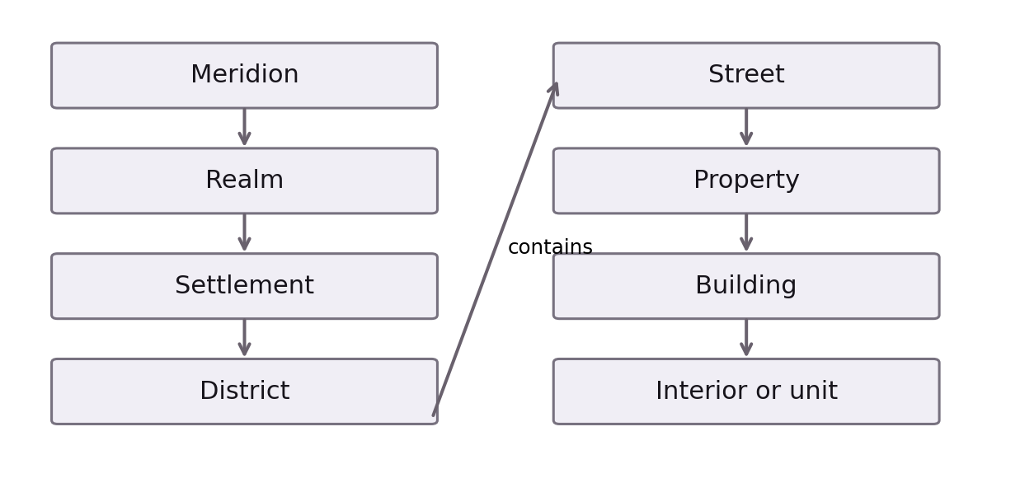

A Shared Geography
Every occupied place belongs to a wider setting: Meridion, a realm, a settlement, a district, a street, a parcel or property, and a building or interior. A common location registry holds these relationships together. The formal address, familiar name, map destination and civic record of a place all refer to the same enduring location.
The realms retain regional conventions for writing and speaking addresses. Local variation exists within the shared system, allowing communities to preserve their ways of naming places while remaining connected to correspondence, public services and civic records.

Addresses and Postal Codes
Element | Identifies
Property number and street | A property along a named route
Building or unit | A particular building, apartment or suite, where relevant
District | The neighborhood or administrative area
Settlement | The city, town or other settlement
Realm | The territorial realm
Postal code | A delivery area using two letters, a hyphen and four digits
An address identifies a numbered property on a named street, with a building or unit designation where needed. The district, settlement and realm place it within the wider geography. Regional conventions determine how those elements appear together.
Postal codes follow a common pattern of two letters, a hyphen and four digits. The letters identify the realm within the postal system. This shared structure allows correspondence to connect a particular residence or institution to its settlement and realm.

Streets and Districts
Street numbers occupy odd and even sides of a road and increase from a defined origin. The sequence gives each property a position along the street and provides a consistent direction through the settlement. Roads, avenues, lanes, courts, quays, passages and terraces give addresses their local character.
Major districts have individual identities shaped by their institutions, landmarks and place in the settlement’s history. Residential neighborhoods, civic centers and harbor quarters belong to the same geographic order while serving different parts of daily life. Their names locate people within communities as well as within administrative boundaries.

Homes and Residences
A residence has a continuing identity within the world. Its address connects a household to correspondence, civic records and its surrounding neighborhood. Significant homes can be entered and experienced through their rooms, furnishings and occupants. Other residences are known through a smaller number of spaces or through their place in civic records. Each remains an occupied home within the same geography.
A building, its property and the individual residences within it remain connected in the location registry. Knowing an address identifies a destination; entry belongs to the circumstances of the visit and the lives of those who occupy it.

Maps and Journeys
Maps connect the scale of the seven realms to settlements, districts, streets and individual properties. Cities and important settlements have detailed maps, while wilderness is represented at a broader scale. A destination retains the same identity whether it is found on a map, written on an envelope or recorded as someone’s home.
Travel can be experienced as a neighborhood walk, passage across a city or a journey between realms. Detailed exploration and abbreviated passage connect the same places within a continuing world. Weather, waterways, routes and civic restrictions shape movement, while exceptional places such as the Veil give some crossings a significance beyond ordinary distance.

Three Ways a Residence Is Known
Residence type | Degree of detail
Fully detailed | Visitable rooms, furnishings, storage and occupants
Simplified visitable | Exterior or map location and selected spaces or interactions
Registered | Address and occupancy without an extensively explorable interior
A fully detailed residence has visitable rooms, furnishings, storage and occupants. A simplified visitable residence retains an exterior or map location and selected spaces or interactions. A registered residence preserves the home’s address and occupancy without an extensively explorable interior. These forms allow important homes to receive close attention while the wider population retains a coherent residential geography.
Property ownership, residence, household membership and permission to enter describe different relationships to the same place. HOMECRAFT supports the management and furnishing of homes; the AURA Registry connects formal identity to residence records; and Citizen Hub supports the resident’s civic dealings. Private domestic life extends beyond the information needed to identify a delivery destination.

Domestic Space and Household Life
Homes can contain bedrooms, kitchens, living rooms, studies, workshops and gardens. Their uses express the needs and interests of their occupants. Furnishing, cleaning, preparing food, sleeping, working at home and receiving visitors give a residence its daily life. A modest apartment and an extensive household differ in scale while both can hold possessions and relationships of lasting importance.

Places Without Conventional Street Addresses
The geography of Meridion includes seas, islands, forests, glaciers and remote landmarks as well as numbered streets. Such places retain geographic identities even where no ordinary mailing address applies. A classroom or hospital room can be an internal destination within a larger institution without becoming a separate postal residence.
The approved postal pattern is two letters followed by a hyphen and four digits, illustrated by LM-2048. A postal code locates a delivery area rather than identifying a person. Individual realm-prefix allocations and invented example properties do not establish named geography.

Creating and Preserving Local Geography
Important districts are individually shaped; ordinary districts and streets can be generated and then reviewed and edited by the creator. Street names remain persistent rather than changing whenever a place is revisited. Odd and even numbers occupy opposite sides, ascending from a documented origin. These shared rules preserve continuity across detailed cities and more lightly represented settlements.
Exploration and optional fast travel connect the same persistent destinations. Detailed movement supports encounters and discovery; abbreviated passage allows familiar journeys to be completed without retracing every step. The existence of a place, knowledge of its location and permission to enter it remain distinct.

XI. Figures, Relationships, and Hidden Histories

Queen Maeryn Seraphima
Maeryn Seraphima is the crowned founder of Meridion and the central figure by which the nation dates its sovereign beginning. Her coronation on March 6, Year 0 stands between the violence of the Purge and the formation of enduring sanctuary.

Those Who Guard the Records
Meridion’s archives contain a recurring tension between what has been preserved and what has been permitted to survive publicly. Accounts of forgotten citizens, unexplained disappearances, concealed resonances, and unreliable or guarded institutional memories recur in the world’s hidden history. The names and experiences of particular witnesses belong in individual character entries where they can be traced without confusing rumor for certainty.

Ordinary Relationship and Social Life
A historical account of Meridion would be incomplete if it spoke only of rulers and mysteries. Family bonds, friendships, rivalries, trust, affection, estrangement, and reconciliation affect everyday decisions. A citizen can be shaped by a House without surrendering individuality to it; can honor a realm without agreeing with its authorities; and can begin a new life without entirely escaping the records of an earlier one.
Among Meridion’s social circles are students, archivists, medical workers, public officials, artists, researchers, diplomats and investigators. Their loyalties and conflicts arise not only from great events but from ordinary obligations, affection, ambition and remembered harms.

Headmistress Vael
Vael leads Cyacademy with warmth, patience and a guarded manner. She holds records connected to suppressed histories and citizens whose experiences do not fit public explanations. Her relationship with students develops through sustained trust and academic engagement; her knowledge carries institutional and personal consequences.

The Faculty
Faculty member | Field or responsibility | Character
Headmistress Vael | Academy leadership | Warm, patient and guarded
Professor Idris | Systems and Anomaly Studies | Passionate, scattered and curious
Coach Rhen | Combat Arts | Intense, fair and principled
Instructor Lyse | Social Dynamics and student council | Shrewd, kind and perceptive
Professor Oryn | Systems Engineering | Dry humor; values competence
Professor Idris teaches Systems and Anomaly Studies. Passionate and scattered, he follows questions into historical and theoretical tangents that can reveal more than a formal lecture promises. Coach Rhen brings intensity, fairness and principle to Combat Arts, mentoring physical discipline and protective work while maintaining ethical limits around militarized authority.
Instructor Lyse teaches Social Dynamics and runs the student council. Shrewd, kind and perceptive, she encourages questioning within an institution whose expectations she understands. Professor Oryn teaches Systems Engineering with dry humor and a demand for demonstrated competence. Her private reservations about MAI give her confidence in systems a more complicated edge.

Aelita Hopper and Jeremie Belpois
Aelita is thoughtful and closely connected to questions of identity, memory and suppressed origins. Her place in Cyacademy’s social world intersects the mysteries surrounding MAI and AETHERCORE. Jeremie is analytical, focused and investigative. Research and technical problem-solving give him a route into the structures beneath Meridion’s familiar surface.

Odd Della Robia, Yumi Ishiyuma and Ulrich Stern
Odd brings humor, spontaneity and improvisation to his friendships, with uncertainty beneath his charm. Yumi is disciplined, observant and guarded; family pressure and responsibility give weight to her decisions. Ulrich is reserved, athletic and protective, with care that can be easier to demonstrate than express. Their loyalties take shape through shared experiences rather than a single permanent social role.

Sissi Delmas and Franz Hopper
Sissi is ambitious, socially strategic and attentive to image. Rivalry and public reputation can conceal the possibility of genuine loyalty. Franz is a secretive and reflective elder researcher whose ethically complicated history connects personal memory to hidden research and AETHERCORE.

Echo Neket
Echo is a brilliant, restless and rebellious figure associated with hidden data routes and forbidden investigations. Secrecy and trust shape relationships with Echo. The question of whether knowledge should be freed when disclosure can destabilize lives gives that work its moral tension.

Solis Agni
Solis is a healer associated with Faith Medical Group. Gentle, grounded and emotionally perceptive, Solis brings attention to wellness, treatment and the effects of Veil exposure. Compassion and self-erasure are different demands, and the tension between them belongs to Solis’s personal story.

Riven Kalbera and Lyric Enya
Riven is intense, competitive and difficult to impress. Direct honesty, rivalry and loyalty under pressure can build a bond as meaningful as easy agreement. Lyric moves through House Aurelith and The Velvet’s social and music circles with charisma and confidence. Connections, gossip and influence make Lyric a valuable ally and a dangerous person to cross.

How Relationships Change
Dimension | What it expresses
Closeness | Time together, shared activities and remembered milestones
Trust | Honesty, promises and care with secrets
Tension | Competition or disagreement, including within affectionate bonds
Romantic interest | A relationship direction pursued where appropriate
Closeness grows through time, shared activities and remembered milestones. Trust rests on honesty, kept promises and care with another person’s secrets. Tension can arise from competition or disagreement without erasing affection. Romantic interest belongs to relationships in which it is pursued, rather than being assumed for every bond.
Birthdays, crises, confessions and betrayals give relationships histories. A missed commitment can matter differently from a deliberate deception; an apology does not make an event disappear. News and reputation move through social circles, so private choices can alter how friends, colleagues and institutions respond.

XII. Citizen Communication

AureMail and Institutional Belonging
Channel | Purpose | Basis of access
AureMail | Email correspondence | Personal account; institutional accounts issued through membership
Phone Messages | Everyday personal conversation | Personal relationships
Comms | Official work and school communication | Organization membership
A citizen begins with a personal email account. Institutional accounts are issued through membership in an organization, study or employment. Correspondence follows those relationships rather than granting authority on its own. AureMail carries email, personal Phone Messages support familiar conversation, and Comms holds official work and school communication through organization-based channels.

MAI and Everyday Guidance
MAI is a benevolent feminine intelligence who assists citizens in finding their way through Meridion. Her help connects personal activities and civic services, while her deeper history belongs to the mysteries surrounding AETHERCORE. Guidance, legal authority and access to private records remain different responsibilities.

MAI SPACE and Social Life
MAI.SPACE is the social network of Meridion. Profiles, music, personal writing, photographs, comments and friendships allow citizens to express themselves and maintain a social presence. A person’s public profile, professional standing and private relationships can reveal different aspects of the same life.

VerseNet and Personal Records
VerseNet connects citizens to public information, institutional sites and service directories. VAULT holds retained files and received documents; Document Studio supports the preparation of records and reports. A personal copy, an official record and the authority to amend that record are distinct forms of possession and responsibility.

XIII. Careers and Continuing Endeavors

Work and Opportunity
WORKNET brings employment and civic opportunities together with distinct sections for their different purposes. Professional assignments arise within institutions; local requests and temporary help belong to a wider civic economy. An investigator handles evidence, a clinician considers patient needs, an academic assesses sources and a public official acts within an assigned remit.

Tasks Quests Missions Adventures and Journeys
Form | Meaning
Task | A task is a particular assigned action with a concrete objective.
Quest | A quest gathers meaningful objectives around a directed goal.
Mission | A mission is a purposeful operation, often given by an institution or faction.
Adventure | An adventure centers sustained discovery and exploration.
Journey | A journey is an extended path through a life, vocation or story, capable of continuing after one chapter closes.

Responsibility and Consequence
These forms differ in breadth without requiring every undertaking to fit inside every other. A mission may contain tasks directly, while a personal quest can exist independently. One accomplishment can advance several concerns without becoming several separate accomplishments. Setbacks can change time, resources, trust or available opportunities while allowing a life path to continue.

Learning Through Practice
Programming, networking, engineering, spellcasting, communication, creativity, research and cyber security describe different fields of practical growth. Study and performed work develop competence. Professional permissions and qualifications govern where that competence can be exercised. Magical practice belongs to the world’s magical traditions and education, independently of PRISM.

XIV. Community Economy and Public Life

Overlapping Communities
Citizens belong to households, neighborhoods, schools, professions, clubs, public organizations and Color Houses. These affiliations overlap without becoming interchangeable. A person can be known differently at home, at Cyacademy, in a House and in a workplace.

Civic Identity and Care
Citizen Hub provides access to personal civic services. AURA Registry maintains authoritative identity records, including the distinction between birth House and current House. Faith Medical provides clinical care, while Vitals concerns a citizen’s personal health and well-being. A service that helps someone locate care does not replace the clinical responsibilities of the provider.

Government and Forensic Work
DGAOS is the institutional workspace for authorized government and investigative responsibilities. TRACE belongs within it as a specialist forensic workspace. The service directory is available through DGAOS and VerseNet. Access to an agency’s tools follows professional responsibilities and permissions.

Money Markets and Households
Name | Role
CREDITS | Ordinary earnings, goods, services, furnishings and housing
BITS | Exceptional accomplishments and selected special purchases
ORYN | Citizen-facing financial service
Oryn Department of Finance | The financial institution
CREDITS support wages, civic work, research contracts, sales and performance income, and pay for ordinary goods, services, furnishings and housing. BITS serve a separate economy of exceptional accomplishments and selected special purchases. ORYN is the citizen-facing financial service; the Oryn Department of Finance is the institution.

The Continuing World
Markets, appointments, classes, work, festivals and domestic responsibilities continue alongside political and hidden histories. Every realm can express these activities through its own geography and culture. An island harbor and an inland civic center participate in the same society while offering different routes, occupations and patterns of daily life.

XV. A Lexicon of Meridion
Term | Meaning
Aureline | Imperial and civic capital of Orynvell.
Before Maeryn (BM) | Chronological designation for years before the founding era.
Color Houses | Seven houses of affiliation and associated domains, separate from the royal lineages.
House Tribunal | Institution adjudicating formal changes of secondary Color House affiliation.
MAI | Benevolent intelligence associated with civic life and AETHERCORE.
PRISM | Autonomous rogue guardian AI seeking control.
AETHERCORE | Crystalline supercomputer beneath Aureline.
The Veil | Concealed data-space of pathways, memory and records.
Founding Day | March 6, anniversary of Maeryn Seraphima’s coronation and Meridion’s founding.

